 Setting up Cody Leaderboard

This document will go over how to set up the leaderboard for the Cody competition. To run the code, you will need MATLAB downloaded on your computer. MATLAB 2023b was used to make these files.

To set up the leaderboard follow these steps:

1. Download the ‘Cody-Ambassador-Contest’ folder.
   * + <https://github.mathworks.com/gulley/Cody-Ambassador-Contest>
2. Install the Cody App.
   * + Go here:  
        <https://github.mathworks.com/gulley/Cody-Ambassador-Contest>
     + Look under releases v1.0  
       <https://github.mathworks.com/gulley/Cody-Ambassador-Contest/releases/tag/v1.0>
     + There you’ll see an MLTBX file.   
       <https://github.mathworks.com/gulley/Cody-Ambassador-Contest/releases/download/v1.0/Cody.Ambassadors.Contest.mltbx>

**Download and double-click to install the app.**

1. Run the ‘CodyAmbassadorsContest.prj’ project file.

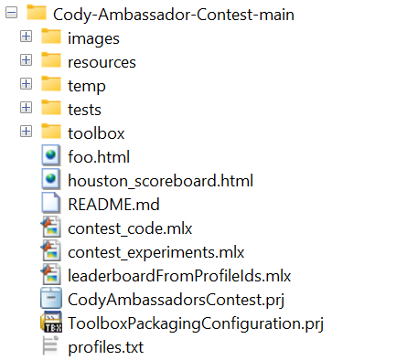

1. Run the ‘scoreboardFromProfiles.mlapp’ App file.

1. Run the MATLAB App

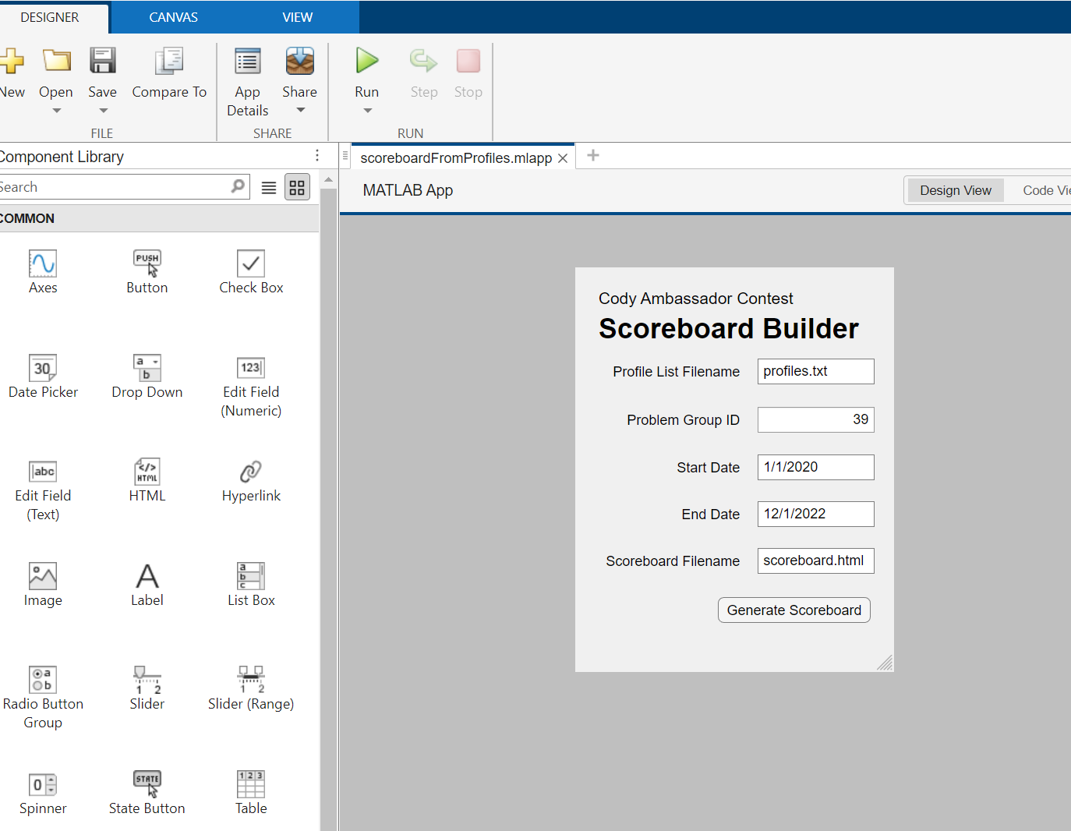

1. The ‘Cody Ambassador Contest Scoreboard Builder’ app will open:
   * Fill in the required fields:
     + Profile List Filename: Edit the profiles.txt (when you generate the scoreboard without editing, it will give a leaderboard with default users)



* + - * The text file should have the **name** and **ID**:

* + profiles.txt: The name and ID of all the participants in row format

* + Problem Group ID: The problem group you have chosen for your Cody competition.

* + The start date and end date for the competition.
  + Scoreboard filename: the name by which you want to save the leaderboard

1. Click on Generate Scoreboard

1. Your scoreboard will be generated on the web!

Feel free to connect with Roshan Hingnekar ([rhingnek@mathworks.com](mailto:rhingnek@mathworks.com)) for any queries.